BÀI THỰC HÀNH TUẦN 5 LAB 13-14
Họ và tên: Đặng Đình An
Lớp 11_THMT
MSSV:1150080001
AndroidManifest.xml
<?xml version="1.0" encoding="utf-8"?>
<manifest xmlns:android="http://schemas.android.com/apk/res/android"
package="com.example.lab4">
<application
android:allowBackup="true"
android:label="@string/app_name"
android:icon="@mipmap/ic_launcher"
android:theme="@style/Theme.Lab4">
<activity android:name=".FaceEmoijActivity" />
<activity android:name=".TopicActivity" />
<activity android:name=".MenuActivity" />
<activity android:name=".LoginActivity"
android:exported="true">
<intent-filter>
<action android:name="android.intent.action.MAIN" />
<category android:name="android.intent.category.LAUNCHER" />
</intent-filter>
</activity>
<activity android:name=".RegisterActivity" />
</application>
</manifest>

MainActivity.java
package com.example.lab4;
import android.os.Bundle;
import androidx.activity.EdgeToEdge;
import androidx.appcompat.app.AppCompatActivity;
import androidx.core.graphics.Insets;
import androidx.core.view.ViewCompat;
import androidx.core.view.WindowInsetsCompat;
public class MainActivity extends AppCompatActivity {
@Override
protected void onCreate(Bundle savedInstanceState) {
super.onCreate(savedInstanceState);
EdgeToEdge.enable(this);
setContentView(R.layout.activity_main);
ViewCompat.setOnApplyWindowInsetsListener(findViewById(R.id.main), (v, insets) -> {
Insets systemBars = insets.getInsets(WindowInsetsCompat.Type.systemBars());
v.setPadding(systemBars.left, systemBars.top, systemBars.right, systemBars.bottom);
return insets;
});
}
}
activity_main.xml
<?xml version="1.0" encoding="utf-8"?>
<androidx.constraintlayout.widget.ConstraintLayout xmlns:android="http://schemas.android.com/apk/res/android"
xmlns:app="http://schemas.android.com/apk/res-auto"
xmlns:tools="http://schemas.android.com/tools"
android:id="@+id/main"
android:layout_width="match_parent"
android:layout_height="match_parent"
tools:context=".MainActivity">
<TextView
android:layout_width="wrap_content"
android:layout_height="wrap_content"
android:text="Hello World!"
app:layout_constraintBottom_toBottomOf="parent"
app:layout_constraintEnd_toEndOf="parent"
app:layout_constraintStart_toStartOf="parent"
app:layout_constraintTop_toTopOf="parent" />
</androidx.constraintlayout.widget.ConstraintLayout>

LoginActivity.java
package com.example.lab4;
import android.content.Intent;
import android.content.SharedPreferences;
import android.os.Bundle;
import android.view.LayoutInflater;
import android.view.View;
import android.widget.EditText;
import android.widget.TextView;
import android.widget.Toast;
import androidx.appcompat.app.AppCompatActivity;
public class LoginActivity extends AppCompatActivity {
EditText edtEmail, edtPassword;
TextView tvLogin;
@Override
protected void onCreate(Bundle savedInstanceState) {
super.onCreate(savedInstanceState);
setContentView(R.layout.activity_login);
edtEmail = findViewById(R.id.edtEmail);
edtPassword = findViewById(R.id.edtPassword);
tvLogin = findViewById(R.id.tvLogin);
TextView tvGoRegister = findViewById(R.id.tvGoRegister);
tvGoRegister.setOnClickListener(v -> {
startActivity(new Intent(LoginActivity.this, RegisterActivity.class));
});
tvLogin.setOnClickListener(v -> {
String email = edtEmail.getText().toString();
String pass = edtPassword.getText().toString();
SharedPreferences pref = getSharedPreferences("USER_DATA", MODE_PRIVATE);
String savedEmail = pref.getString("email", "");
String savedPass = pref.getString("password", "");
if (!email.equals(savedEmail) || !pass.equals(savedPass)) {
Toast.makeText(this, "Sai email hoặc mật khẩu!", Toast.LENGTH_SHORT).show();
return;
}
// Custom Toast
View layout = LayoutInflater.from(this).inflate(R.layout.toast_layout, findViewById(android.R.id.content), false);
TextView tvToastText = layout.findViewById(R.id.tvToastText);
tvToastText.setText("Đăng nhập thành công!");
Toast toast = new Toast(this);
toast.setView(layout);
toast.setDuration(Toast.LENGTH_LONG);
toast.show();
startActivity(new Intent(LoginActivity.this, MenuActivity.class));
});
}
}
activity_login.xml
<?xml version="1.0" encoding="utf-8"?>
<LinearLayout xmlns:android="http://schemas.android.com/apk/res/android"
android:orientation="vertical"
android:layout_width="match_parent"
android:layout_height="match_parent"
android:background="@color/gray">
<FrameLayout
android:layout_width="match_parent"
android:layout_height="300dp">
<View
android:layout_width="match_parent"
android:layout_height="300dp"
android:background="@drawable/bg_top"/>
<TextView
android:layout_width="wrap_content"
android:layout_height="wrap_content"
android:layout_gravity="end"
android:layout_marginTop="220dp"
android:layout_marginEnd="30dp"
android:text="@string/login"
android:textColor="@color/white"
android:textSize="20sp"/>
</FrameLayout>
<!-- EMAIL -->
<EditText
android:id="@+id/edtEmail"
android:layout_width="match_parent"
android:layout_height="50dp"
android:layout_marginHorizontal="30dp"
android:layout_marginTop="50dp"
android:background="@drawable/edt_email"
android:hint="@string/email"
android:paddingStart="50dp"
android:paddingVertical="10dp"
android:drawablePadding="10dp"
android:textSize="18sp"/>
<!-- PASSWORD -->
<EditText
android:id="@+id/edtPassword"
android:layout_width="match_parent"
android:layout_height="50dp"
android:layout_marginHorizontal="30dp"
android:layout_marginTop="20dp"
android:background="@drawable/edt_password"
android:hint="@string/password"
android:paddingStart="50dp"
android:paddingVertical="10dp"
android:drawablePadding="10dp"
android:textSize="18sp"/>
<TextView
android:layout_width="wrap_content"
android:layout_height="wrap_content"
android:layout_gravity="end"
android:layout_marginTop="10dp"
android:layout_marginEnd="30dp"
android:text="@string/forgot_pass"
android:textColor="@color/black"
android:textSize="14sp"/>
<TextView
android:id="@+id/tvLogin"
android:layout_width="match_parent"
android:layout_height="50dp"
android:layout_marginHorizontal="30dp"
android:layout_marginTop="50dp"
android:background="@drawable/bg_login"
android:gravity="center"
android:text="@string/login"
android:textColor="@color/white"
android:textSize="18sp"/>
<TextView
android:id="@+id/tvGoRegister"
android:layout_width="wrap_content"
android:layout_height="wrap_content"
android:layout_gravity="center"
android:layout_marginTop="20dp"
android:text="Chưa có tài khoản? Đăng ký"
android:textColor="@color/black"
android:textSize="16sp"/>
</LinearLayout>

RegisterActivity.java
package com.example.lab4;
import android.content.Intent;
import android.content.SharedPreferences;
import android.os.Bundle;
import android.widget.EditText;
import android.widget.TextView;
import android.widget.Toast;
import androidx.appcompat.app.AppCompatActivity;
public class RegisterActivity extends AppCompatActivity {
EditText edtEmail, edtPassword, edtConfirm;
TextView tvRegister;
@Override
protected void onCreate(Bundle savedInstanceState) {
super.onCreate(savedInstanceState);
setContentView(R.layout.activity_register);
edtEmail = findViewById(R.id.edtRegEmail);
edtPassword = findViewById(R.id.edtRegPassword);
edtConfirm = findViewById(R.id.edtRegConfirmPassword);
tvRegister = findViewById(R.id.tvRegister);
tvRegister.setOnClickListener(v -> {
String email = edtEmail.getText().toString();
String pass = edtPassword.getText().toString();
String confirm = edtConfirm.getText().toString();
if(email.isEmpty() || pass.isEmpty() || confirm.isEmpty()){
Toast.makeText(this, "Vui lòng nhập đầy đủ thông tin!", Toast.LENGTH_SHORT).show();
return;
}
if(!pass.equals(confirm)){
Toast.makeText(this, "Mật khẩu không khớp!", Toast.LENGTH_SHORT).show();
return;
}
// Lưu SharedPreferences
SharedPreferences preferences = getSharedPreferences("USER_DATA", MODE_PRIVATE);
SharedPreferences.Editor editor = preferences.edit();
editor.putString("email", email);
editor.putString("password", pass);
editor.apply();
Toast.makeText(this, "Đăng ký thành công!", Toast.LENGTH_SHORT).show();
// Quay lại Login
startActivity(new Intent(RegisterActivity.this, LoginActivity.class));
finish();
});
}
}
activity_register.xml
<?xml version="1.0" encoding="utf-8"?>
<LinearLayout xmlns:android="http://schemas.android.com/apk/res/android"
android:orientation="vertical"
android:layout_width="match_parent"
android:layout_height="match_parent"
android:background="@color/gray">
<FrameLayout
android:layout_width="match_parent"
android:layout_height="300dp">
<View
android:layout_width="match_parent"
android:layout_height="300dp"
android:background="@drawable/bg_top"/>
<TextView
android:layout_width="wrap_content"
android:layout_height="wrap_content"
android:layout_gravity="end"
android:layout_marginTop="220dp"
android:layout_marginEnd="30dp"
android:text="@string/register"
android:textColor="@color/white"
android:textSize="20sp"/>
</FrameLayout>
<!-- EMAIL -->
<EditText
android:id="@+id/edtRegEmail"
android:layout_width="match_parent"
android:layout_height="50dp"
android:layout_marginHorizontal="30dp"
android:layout_marginTop="50dp"
android:background="@drawable/edt_email"
android:hint="@string/email"
android:paddingStart="50dp"
android:paddingVertical="10dp"
android:drawablePadding="10dp"
android:textSize="18sp"/>
<!-- PASSWORD -->
<EditText
android:id="@+id/edtRegPassword"
android:layout_width="match_parent"
android:layout_height="50dp"
android:layout_marginHorizontal="30dp"
android:layout_marginTop="20dp"
android:background="@drawable/edt_password"
android:hint="@string/password"
android:paddingStart="50dp"
android:paddingVertical="10dp"
android:drawablePadding="10dp"
android:textSize="18sp"/>
<!-- CONFIRM PASSWORD -->
<EditText
android:id="@+id/edtRegConfirmPassword"
android:layout_width="match_parent"
android:layout_height="50dp"
android:layout_marginHorizontal="30dp"
android:layout_marginTop="20dp"
android:background="@drawable/edt_password"
android:hint="@string/confirm_password"
android:paddingStart="50dp"
android:paddingVertical="10dp"
android:drawablePadding="10dp"
android:textSize="18sp"/>
<!-- BUTTON REGISTER -->
<TextView
android:id="@+id/tvRegister"
android:layout_width="match_parent"
android:layout_height="50dp"
android:layout_marginHorizontal="30dp"
android:layout_marginTop="50dp"
android:background="@drawable/bg_login"
android:gravity="center"
android:text="@string/register"
android:textColor="@color/white"
android:textSize="18sp"/>
</LinearLayout>

strings.xml
<resources xmlns:tools="http://schemas.android.com/tools">
<string name="app_name">Lab4</string>
<string name="login">Login</string>
<string name="email">Email</string>
<string name="password">Password</string>
<string name="forgot_pass">Forgot password?</string>
<string name="no_account">Dont have an account?</string>
<string name="register">Register</string>
<string name="confirm_password">Confirm Password</string>
<!-- Menu Topics -->
<string name="txt_mess">Essentials</string>
<string name="txt_flight">While Traveling</string>
<string name="txt_hospital">Help / Medical</string>
<string name="txt_hotel">At the hotel</string>
<string name="txt_restaurant">At the Restaurant</string>
<string name="txt_coctail">At the Bar</string>
<string name="txt_store">At the Store</string>
<string name="txt_work">Work</string>
<string name="txt_time">Time</string>
<string name="txt_education">Education</string>
<string name="txt_movie">Entertainment</string>
</resources>
colors.xml
<?xml version="1.0" encoding="utf-8"?>
<resources>
<color name="purple_200">#319FFF</color>
<color name="purple_500">#1E88E5</color>
<color name="purple_700">#1E88E5</color>
<color name="teal_200">#FF03DAC5</color>
<color name="teal_700">#FF018786</color>
<color name="black">#FF000000</color>
<color name="white">#FFFFFFFF</color>
<color name="orange">#FB8C00</color>
<color name="gray">#EAE5E3</color>
<color name="orangeMid">#F4511E</color>
</resources>
Kết quả
Login

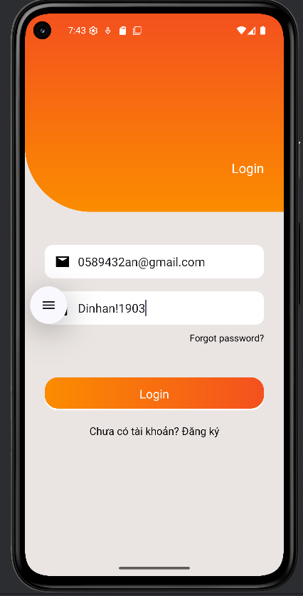
Khi Login thành công
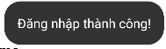
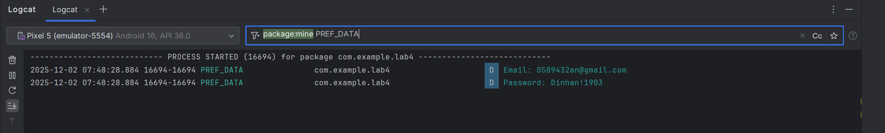

Register
